Supply List for Grade 2 (2022-2023) Please label all school supplies with your childs’ name!

2 - zipper pouches 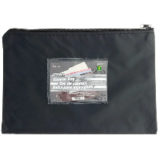15” by 10.2”(you can get these at the dollar store)
2- scribblers (narrow ruled) No coiled scribblers please
2 - exercise book notebooks ½ blank 1/2 lined (Hilroy)
4 - pocket folders (with 2 inside pockets/ black, yellow, blue, red)
3 - duotangs - green, red, yellow

3- large glue sticks
1- Bottle of Glue
24 - Sharpened pencils
1- Pencil sharpener with a catch basin
3 - White erasers
1- Pair of children’s scissors
2 - Package of crayons (24’s)
1-package of colored pencils

1 - medium size pencil box or pencil case
1- package of ordinary thick markers (no scents please)
2 - white board markers
1 - coloring/activity book for indoor lunch
2 large plastic (zip lock) bags
1 pair of inexpensive headphones
1- refillable water bottle

-Indoor footwear (sneakers) to be kept in school starting in October

This supply list was constructed with that budget in mind. Great places to shop for these supplies: Wal-Mart (Rollback to School Sale) and Staples (Back to school sale) Please label all school supplies!

**Please note we are a scent sensitive school. ** See you in September!

