Grade 1 Supply List 2023/2024
Dear Families,
Below is a list of items that your child will need for school. You do not need to purchase any school supplies for your child. Instead, you will pay a fee of $30.00 to the office and the school will purchase all supplies needed.
In addition to $30.00, your child must also have:
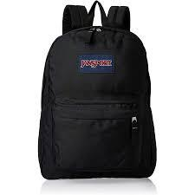  Backpack | 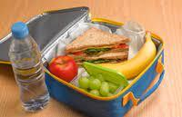  Water bottle, snack, and lunch Your child will need to bring their own snack and lunch to school every day. Please ensure it is nut free.
Indoor shoes  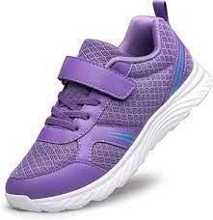  With non-marking soles for Physical Education class. These shoes will be kept in school and not go home. Please no shoelaces until your child learns how to tie their shoes. | Change of clothing  Top, bottom, underwear, and socks in a bag  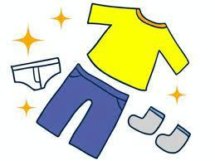  labeled with your child’s name. This will be kept in school.
**Please label all items with your child’s name**

See you in September!

